# What Did You Just Say?

Designed and Developed By

Abani Bhusan Das

(18101BD001)

Description

What Did You Just Say? is a Beat Em Up 2D game where the player takes control of a brawler who was just passing and is landed by insults from other brawlers.

The Game is made using UNITY3D and 3D viewport is used.

What Did You Just Say? is basically a meme game where the insults are supposed to be infuriating and funny at the same time.

Gameplay

1. **Goal**

What Did You Just Say? has a simple gameplay, you just have to go, and beat the thugs up. That’s it.

If the user wins then user progress into the next level

If the user loses then he’s landed by insults and he has to try again

1. **Player**

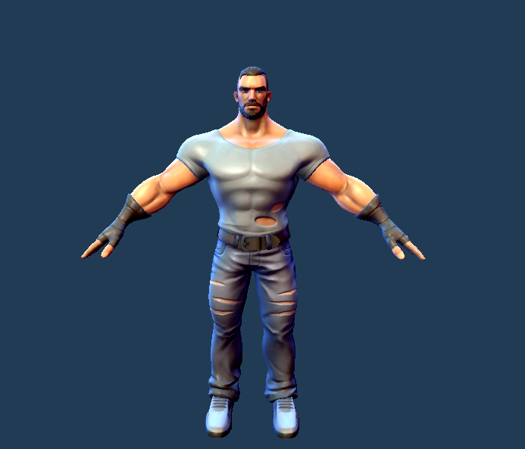

The user takes control of this brawler whose name is Trevor.

1. **Controls**

**The player has can move left right and jump up in the air and has key binds for Punch and Kick**

1. **Enemies**

**Enemies in this game are street thugs. They would be using insults to infuriate the player and would be using phrases like “Walking Like A Lady Eh !!”**

**As the Level progress the enemies would get much tougher and would be harder to defeat and as the level progress a new verbal abuse would come.**

1. **Story and Level**

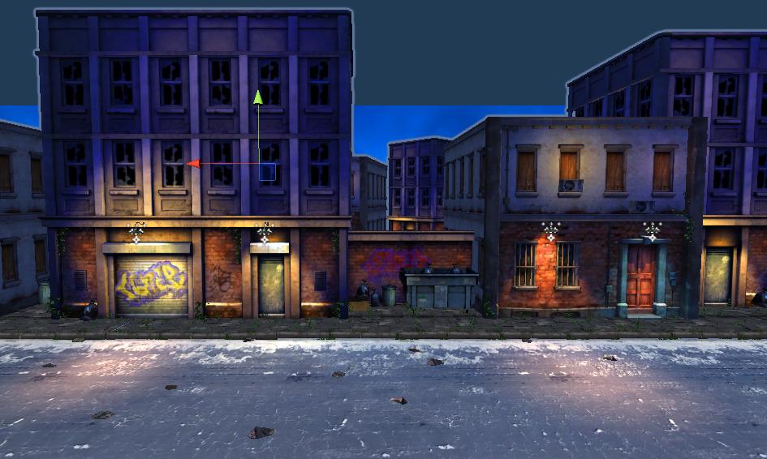

The game sets in 15 Yemen Road, Yemen where our main character went to buy groceries but was insulted by street thugs.

Since our player is the kind of man who doesn’t stand insults, he starts beating them up and the brawl begins.

The game will consist a total of 10 levels with the difficulty of the level increasing as the level progresses.

The number of enemies will increase and will deal with less damage from you while inflicting more damage to you.

The final level will have a boss who is known as the Master Abuser and will verbally abuse you every second.

Music and Sound Effects

The Game has a background music playing and has sound effects for punch, kick and of course! The Verbal Abuses, The very core of this game

Other Ideas

If any other ideas strike, Pin Down Here.